Flutter Lifecycle
In Flutter, lifecycle refers to the stages a widget goes through from creation to removal, or the states an app goes through while running in the foreground or background.
There are two important lifecycle concepts in Flutter:
- Widget lifecycle — how a widget is created, updated, and destroyed.
- App lifecycle — whether the app is resumed, inactive, paused, or detached.

1. Widget lifecycle in Flutter
For a StatefulWidget, the lifecycle methods belong to its State class.
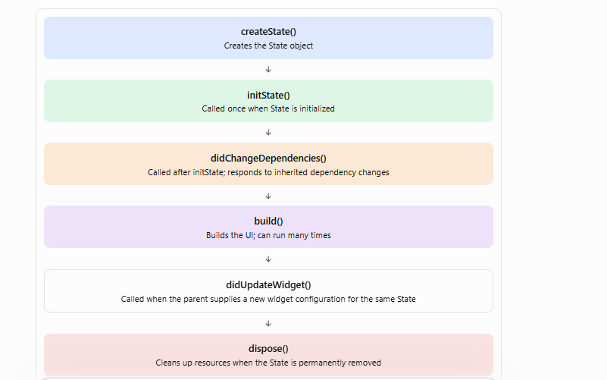

Simplified flow: didUpdateWidget and build can repeat; dispose occurs when the State is removed permanently.

Important lifecycle methods
Method | When it is called | Typical use
createState() | When Flutter creates the widget's State | Create the State object
initState() | Once per State object's lifetime | Initialize controllers, listeners, API requests
didChangeDependencies() | After initialization and when inherited dependencies change | Access Theme, MediaQuery, or inherited data
build() | Whenever Flutter needs to build or rebuild the UI | Return widgets
didUpdateWidget() | When the widget configuration changes but the State is reused | Respond to changed widget properties
deactivate() | When the State is removed from the tree temporarily | Handle temporary removal if necessary
dispose() | When the State is permanently removed | Cancel timers, dispose controllers, remove listeners

2. Example of a Flutter widget lifecycle
dart
import 'package:flutter/material.dart';

class LifecycleDemo extends StatefulWidget {
const LifecycleDemo({super.key});

@override
State<LifecycleDemo> createState() =>
_LifecycleDemoState();
}

class _LifecycleDemoState extends State<LifecycleDemo> {
@override
void initState() {
super.initState();
debugPrint('initState');
}

@override
void didChangeDependencies() {
super.didChangeDependencies();
debugPrint('didChangeDependencies');
}

@override
void didUpdateWidget(covariant LifecycleDemo oldWidget) {
super.didUpdateWidget(oldWidget);
debugPrint('didUpdateWidget');
}

@override
Widget build(BuildContext context) {
debugPrint('build');

return const Scaffold(
body: Center(
child: Text('Flutter Lifecycle'),
),
);
}

@override
void deactivate() {
debugPrint('deactivate');
super.deactivate();
}

@override
void dispose() {
debugPrint('dispose');
super.dispose();
}
}
When this widget is first inserted into the tree, the typical log order is:
text
initState
didChangeDependencies
build
didUpdateWidget() runs when Flutter reuses the same State object with a new widget configuration. dispose() runs when that State is permanently removed.
Important: Call super.initState(), super.didUpdateWidget(), and the corresponding superclass methods when overriding lifecycle methods, as appropriate.

3. Flutter app lifecycle
The app lifecycle describes the application's overall visibility and execution state. Flutter exposes it through AppLifecycleState.
State | Meaning
resumed | App is in the foreground and can receive user input
inactive | App is visible or transitioning but is not receiving normal input focus
hidden | App's views are hidden from the user
paused | App is in the background and not visible
detached | Flutter's engine is running without an attached host view
The exact state transitions depend on the platform. For example, Android and iOS can transition through different states when an app is backgrounded.

How to listen for app lifecycle changes
Use WidgetsBindingObserver:
dart
import 'package:flutter/material.dart';

class AppLifecycleDemo extends StatefulWidget {
const AppLifecycleDemo({super.key});

@override
State<AppLifecycleDemo> createState() =>
_AppLifecycleDemoState();
}

class _AppLifecycleDemoState
extends State<AppLifecycleDemo>
with WidgetsBindingObserver {

@override
void initState() {
super.initState();
WidgetsBinding.instance.addObserver(this);
}

@override
void didChangeAppLifecycleState(
AppLifecycleState state,
) {
debugPrint('App lifecycle: $state');

if (state == AppLifecycleState.resumed) {
// App returned to the foreground.
} else if (state == AppLifecycleState.paused) {
// App moved to the background.
}
}

@override
void dispose() {
WidgetsBinding.instance.removeObserver(this);
super.dispose();
}

@override
Widget build(BuildContext context) {
return const Scaffold(
body: Center(child: Text('App Lifecycle')),
);
}
}

4. Common Flutter lifecycle interview questions
- Q: What is the difference between initState() and build()? initState() runs once per State object's lifetime. build() can run many times.
- Q: Can we call an API in initState()? Yes. You can start an asynchronous request there, then update the UI safely when the result arrives, checking mounted when needed.
- Q: Why do we use dispose()? To release resources such as TextEditingController, AnimationController, stream subscriptions, and listeners.
- Q: Can we use BuildContext in initState()? You have a context, but inherited dependencies should generally be accessed in didChangeDependencies() rather than through dependency-creating lookups in initState().
- Q: What is the difference between deactivate() and dispose()? deactivate() is temporary removal from the tree; dispose() is permanent cleanup.
- Q: Does calling setState() call initState() again? No. It schedules a rebuild; it does not reinitialize the State object.
- Q: How can we detect when a user returns to the app? Listen for AppLifecycleState.resumed.

5. Which lifecycle do you want to learn in more detail?
Choose a topic
widget Widget lifecycle methods with examples
App lifecycle (foreground/background)
Lifecycle when navigating between screens
Lifecycle with Provider, Riverpod, or BLoC
Learning goal
Beginner explanation
interview Interview questions and answers
Real-world coding examples
Continue

